SKCHEC

Adarsh Arun Hoskere XI A

Adarsh Sasikumar XI C

Rishabh Kartik Jawagal XI C

School: SKCHEC

Year/Class:2022

SOLUCIONES DE LA PHYSICA

In this project we provide the students of class 11 a platform to quickly check their answers by providing the input of the given information in the questions. This helps the students to save time as they don’t have to search across the internet to verify their answers.

ACKNOWLEDGEMENT

The success of a project depends upon the persistent efforts of an individual projecting it and the sustained support received from a few others who are equally responsible for their precious appreciation of such endeavors. My strength is all due to my honorable Principal Deepa Sridhar who has been an unending source of inspiration and support towards accomplishment of this project.

I would like to express my deepest sense of gratitude to my computer teacher Sriranjini Sridhar and Padma Pavani without whom I could not have successfully completed this project.

I would also thank all my friends who helped me create such a project.

My personal gratitude is extended towards my parents, who have been a constant source of encouragement and support in the success of this project. Last but not the least I want to thank Almighty for enlightening, strengthening and guiding me in the completion of the project.

**CERTIFICATE**



**Sri Kumaran Children’s Home, CBSE**

**Bangalore**

**Project Certificate**

This is to certify that

Adarsh Arun Hoskere

Of Class XI has successfully completed the project work titled SOLUCIONES DE LA PHYSICA under the guidance of

Ms. Sriranjini Sridhar during the academic year 2021 – 2022 in partial fulfillment of Computer Science practical examination conducted by **AISSCE.**

_____________________ _____________________

**Internal Examiner External Examiner**

___________________________

**Principal**

Date of Practical Examination: ___________________

Name of the Candidate: __________________________

Examination Centre: ____________________________

Table of Contents

1. Introduction – Project Synopsis 1

2. System Specifications 1

3. Flow Diagram 2

4. Source Code 3

5. Output Screen shots 4

6. Scope for improvement 20

7. References/Bibliography 21

# Introduction – Project Synopsis

In this project we provide the students of class 11 a platform to quickly check their answers by providing the input of the given information in the questions. This helps the students to save time as they don’t have to search across the internet to verify their answers. This is a menu-based application for the topics in Physics and calculate the mechanics based on the student choice

# System Specifications

**Hardware requirements:**

Windows 7 or more

4GB RAM  
5GB free disk space

**Software Requirements:**

Idle Shell  
Python 3.9

# Flow Diagram

USER INPUT FOR TOPIC NUMBER

PRINT INTRODUCTION AND AVAILABLE TOPICS

USER INPUT FOR SUBTOPIC NUMBER

PRINT AVAILABLE SUBTOPICS

ELSE

IF INPUT=0

IF INPUT=0

USER INPUT FOR REQUIRED VARIABLES IN THE CHOSEN SUBTOPIC

CALCULATE VALUES BASED ON THE FORMULA

PRINT VARIABLE VALUES AND THE FINAL ANSWER

ELSE

# Source Code



# Output Screen shots

Main Menu

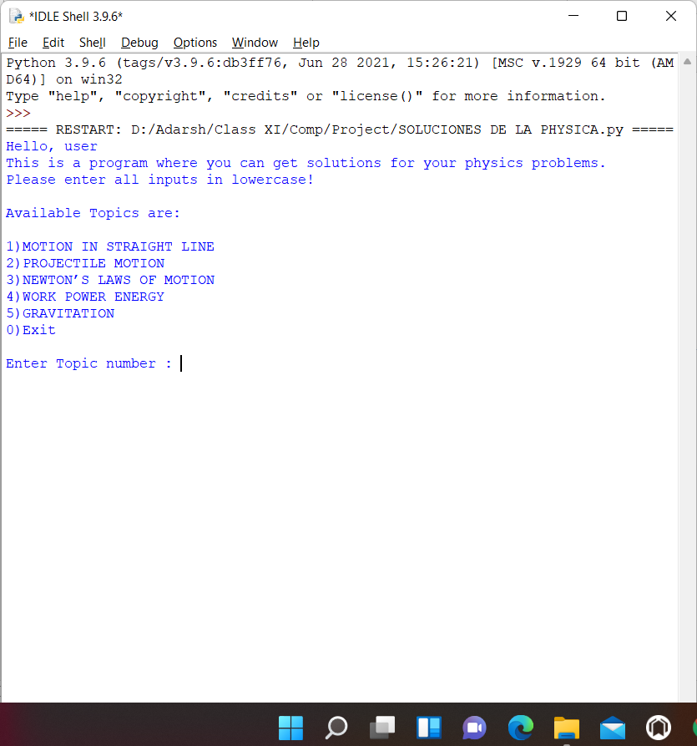

Sub Menu

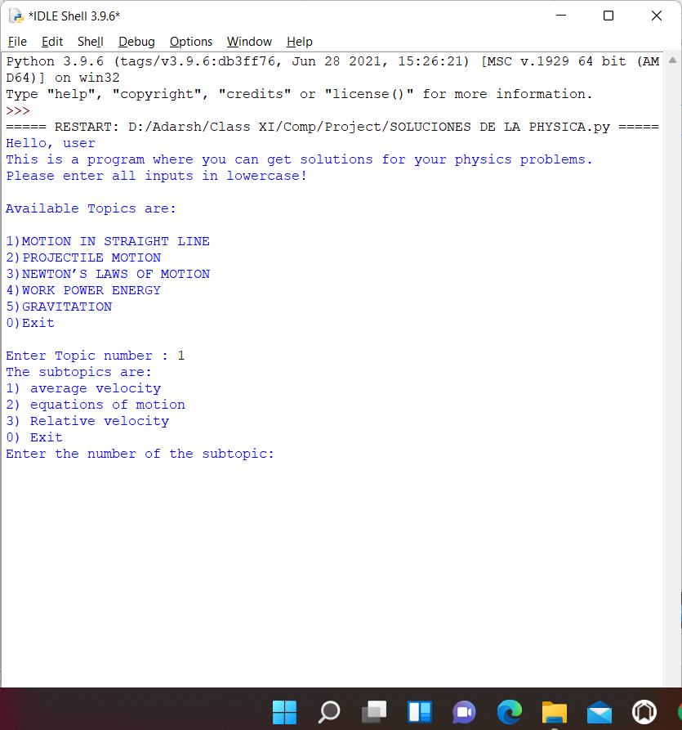

Average Velocity – Input/Output

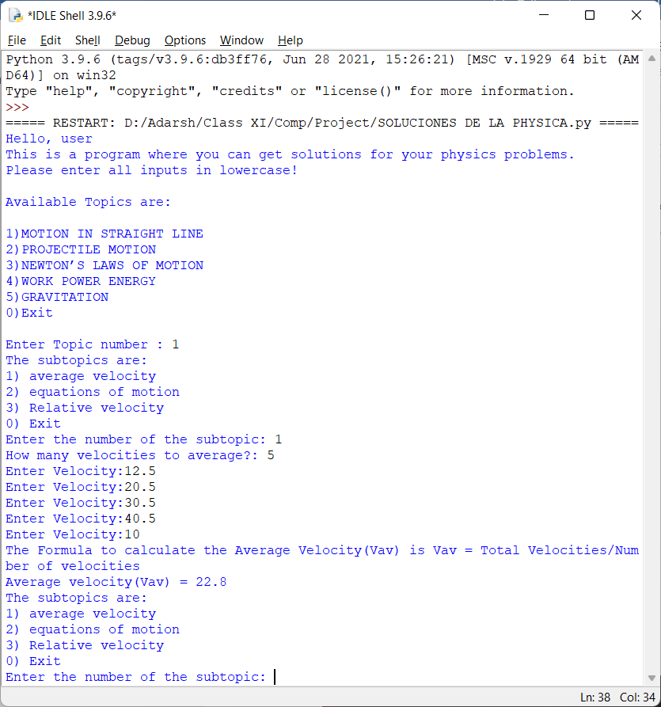

Equations of motion – Input/Output

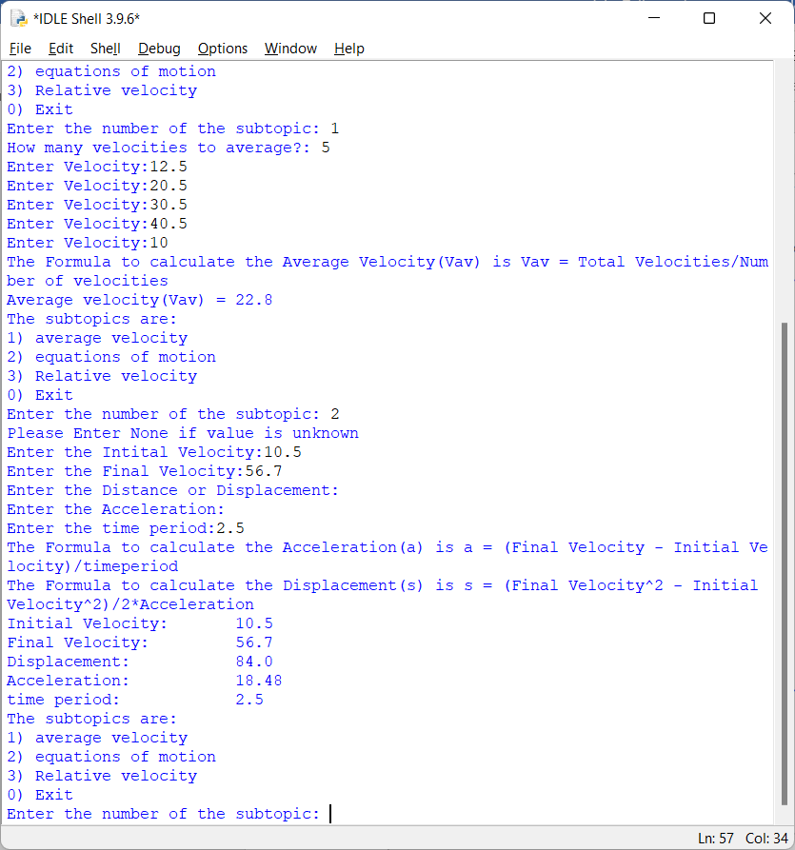

Exit from the sub menu

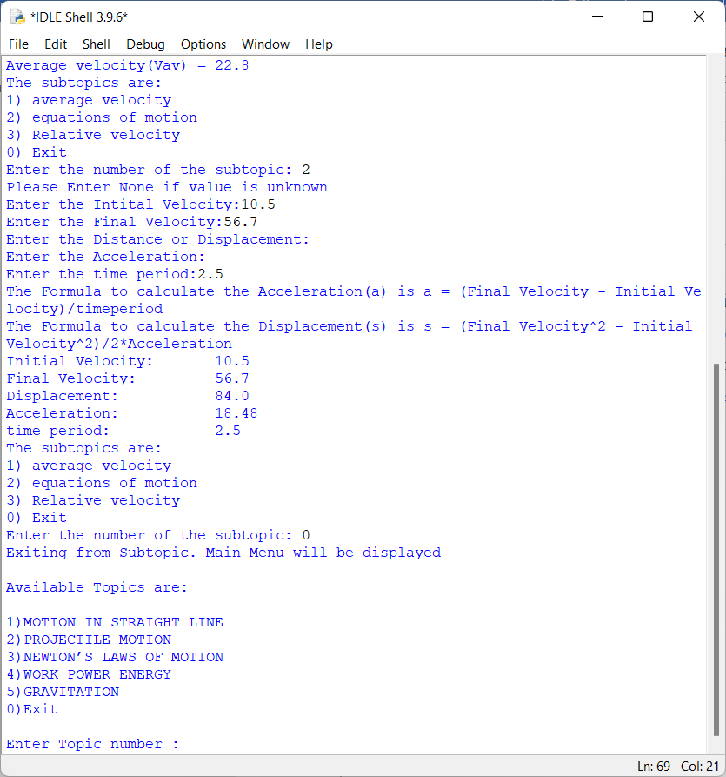

Projectile Motion – Menu

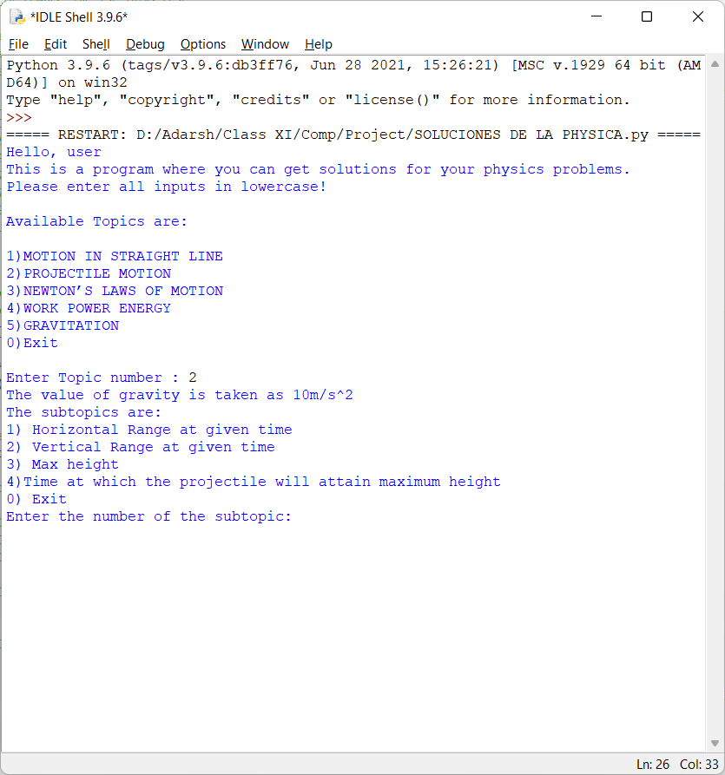

Horizontal Range – Input/Output

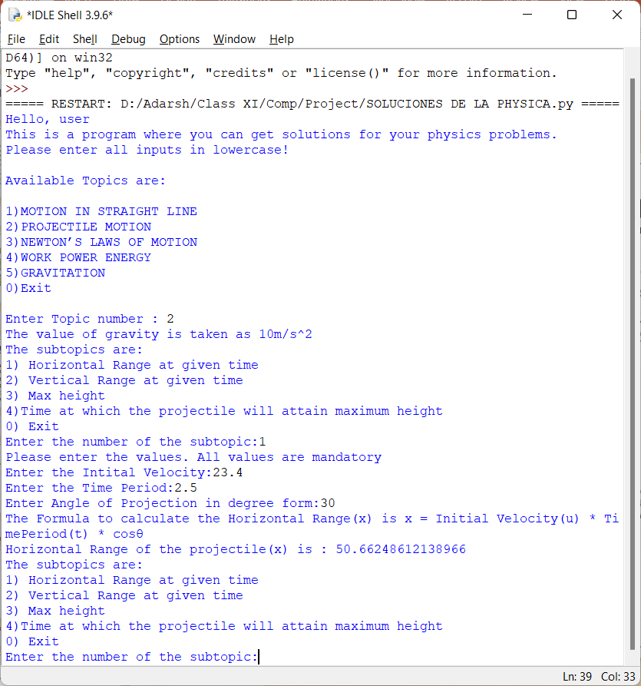

Max height – Input/Output

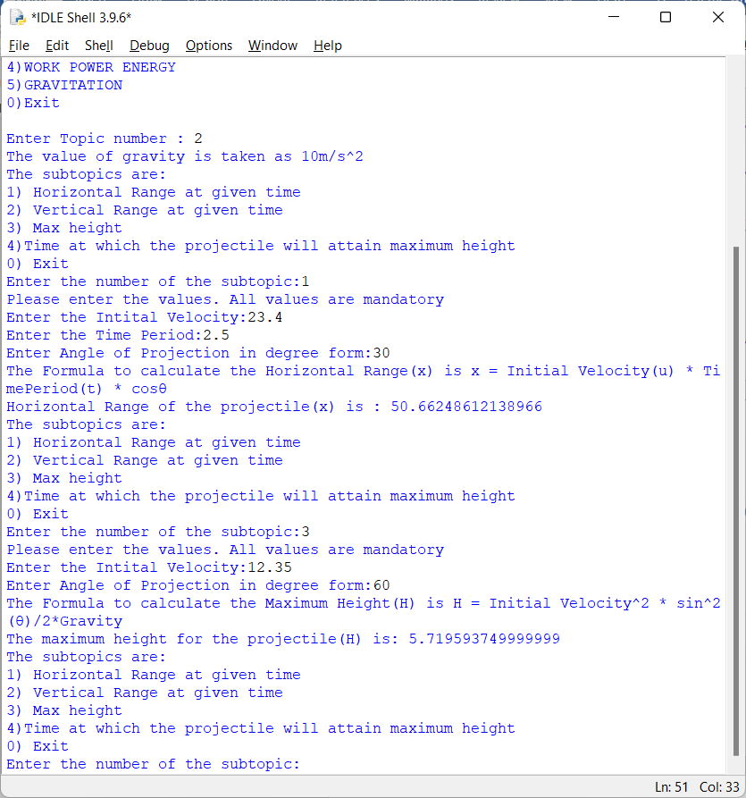

Newton’s Law of Motion – Menu

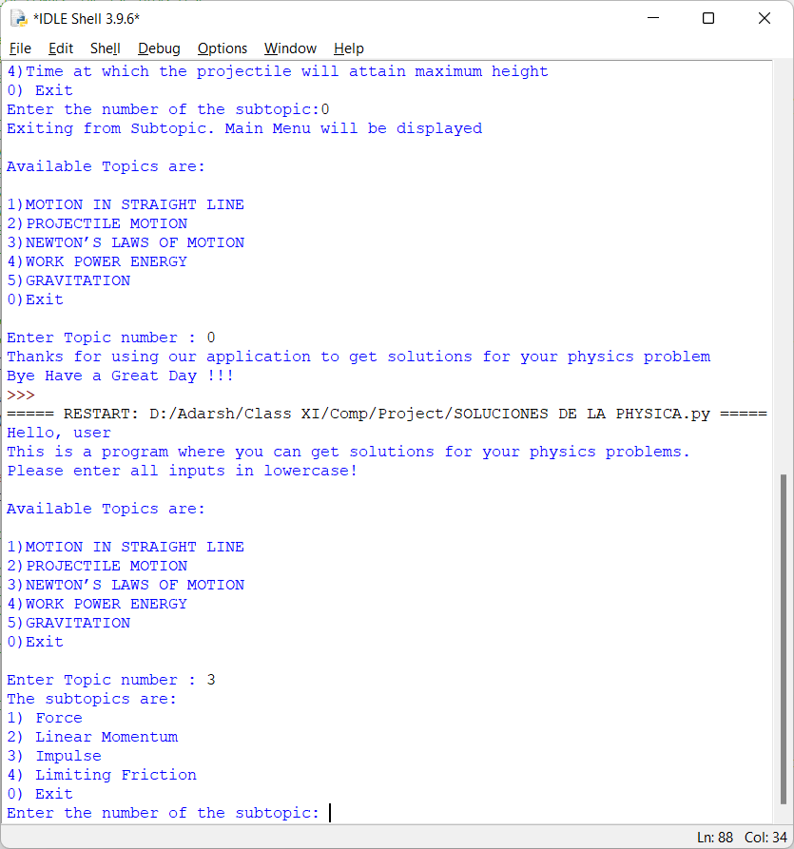

Linear Momentum – Input/Output

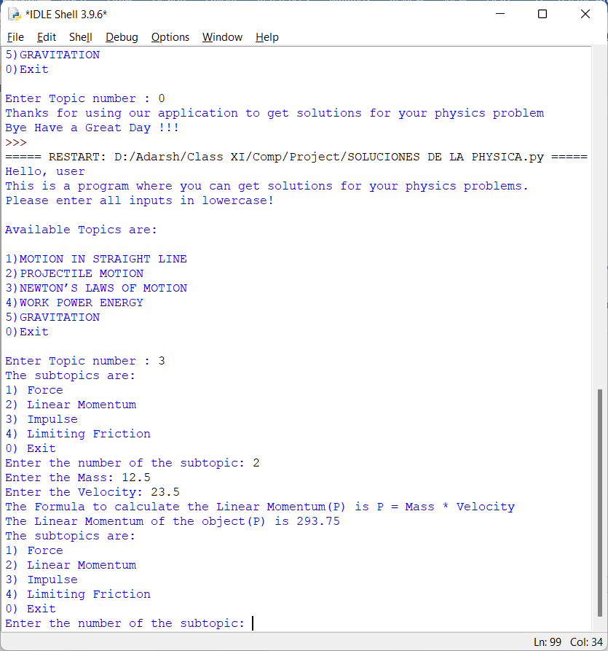

Impulse – Input/Output

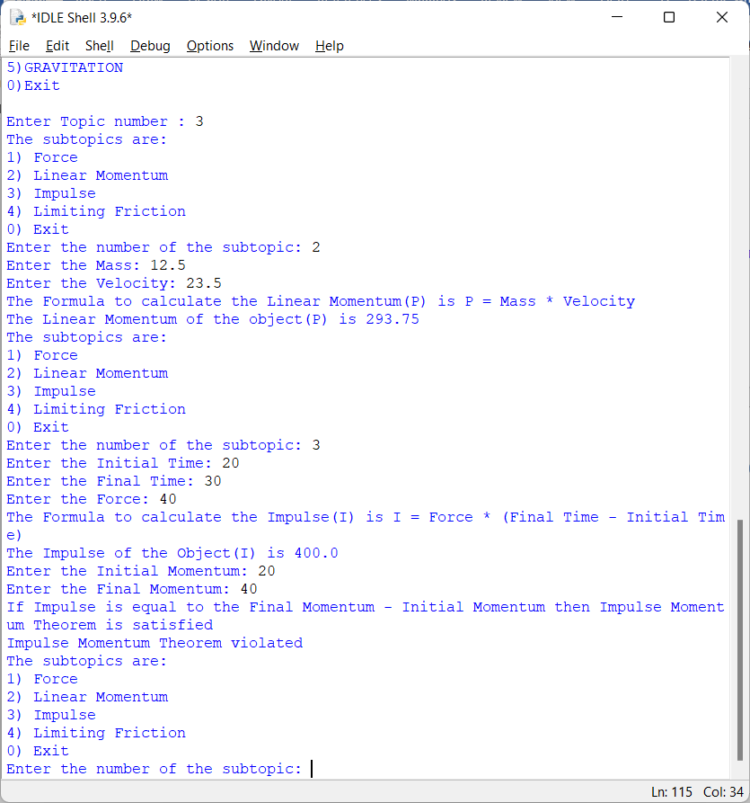

Work Power Energy – Menu

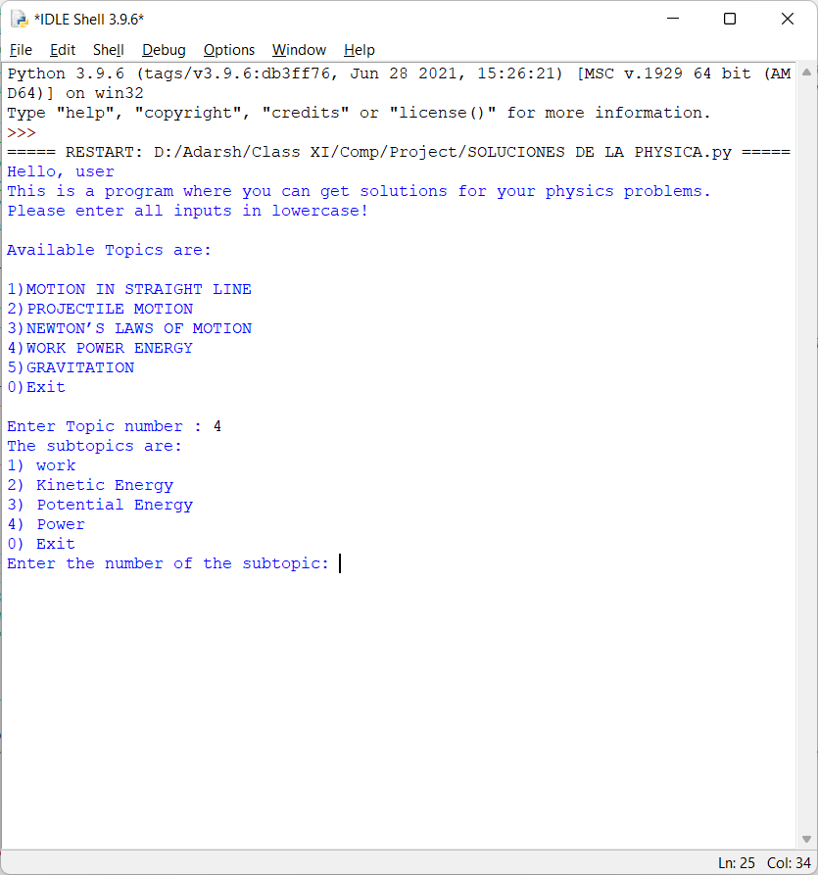

Power – Input/Output

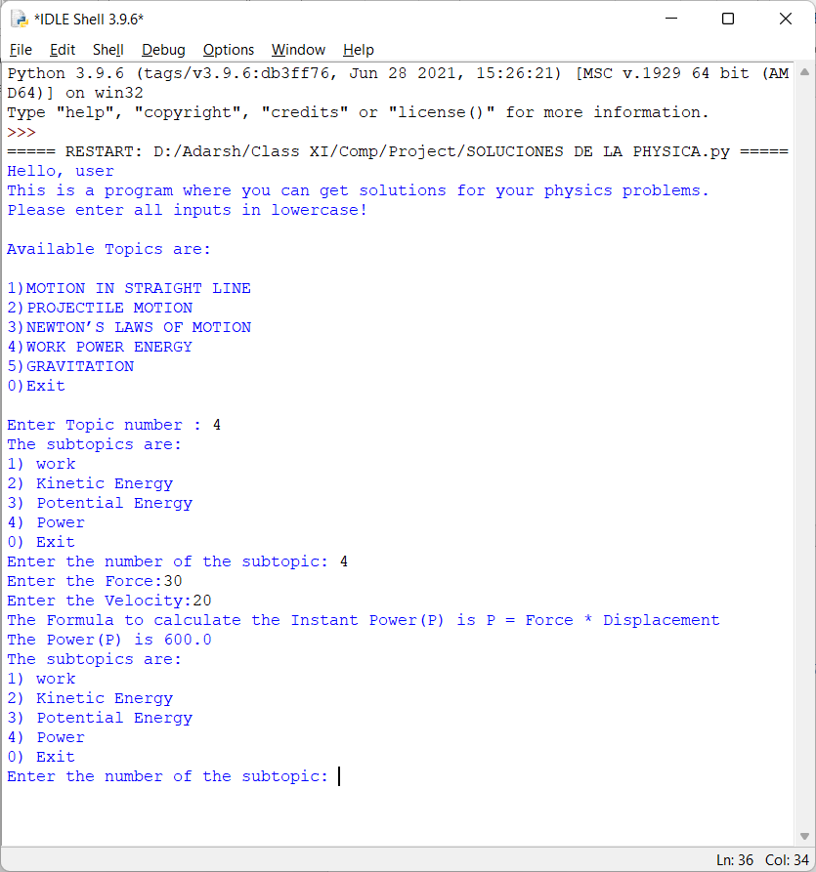

Gravitation – Menu

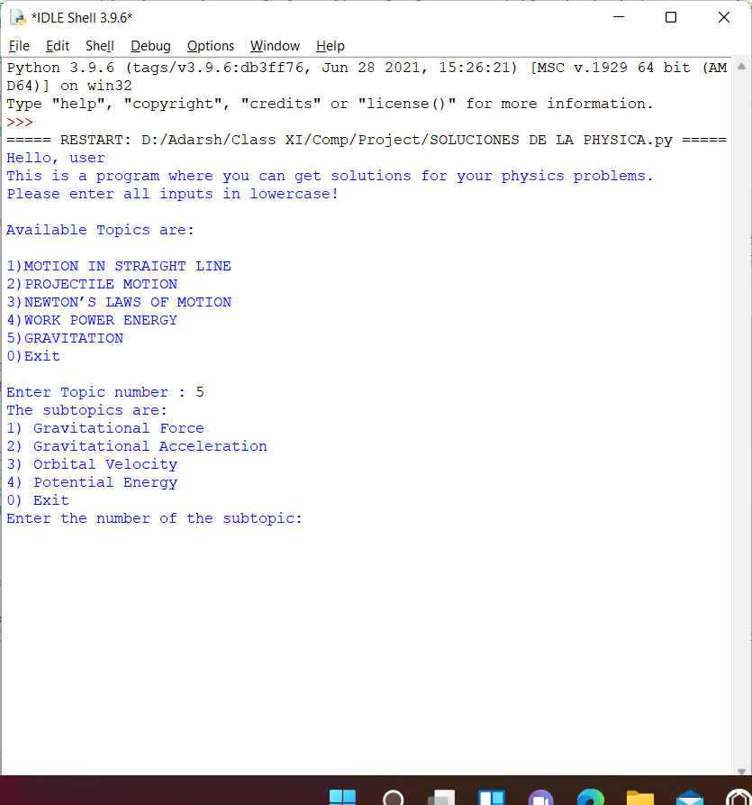

Gravitational Acceleration – Input/Output

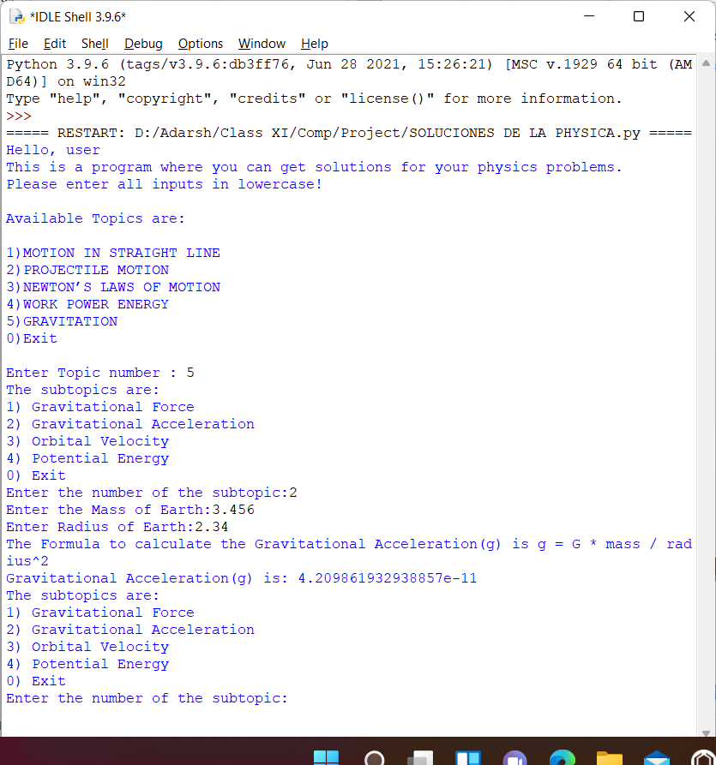

Main menu – Exit

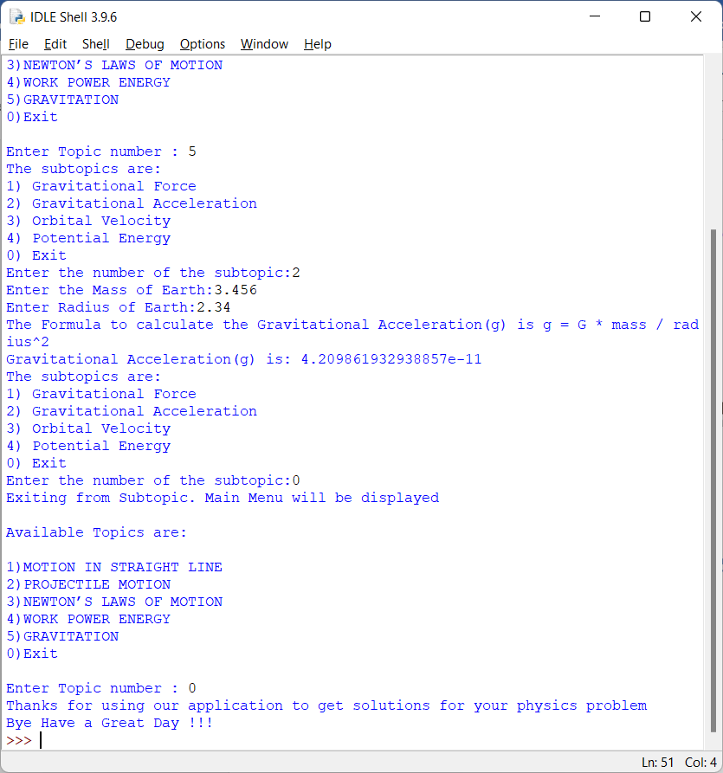

# Scope for improvement

* More user friendly
* Add few more chapters

# References/Bibliography

1. Computer Science With Python – Sumit Arora
2. Guidance and Suggestions from our Computer Teachers –  
   Ms Sriranjini Sridhar and Ms Padma Pavani